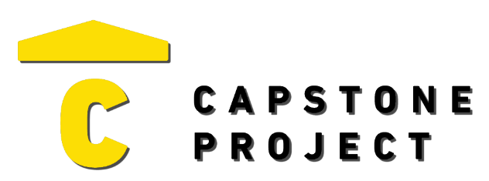
USER FEEDBACK
User Name: Caidan Netzer
What are your thoughts on the project overall?
I thought it was a solid project. It had a lot more features than I expected and the design was clean.

Was the project enjoyable? What was your favorite part of the project?
It was enjoyable. I liked the mythology names for the devices, that was a creative touch.
What changes would improve the project?
Not much honestly. Maybe the dashboard could show a little more info at a glance. Like the last time the system was armed.

Capstone Project Ratings:
Project Technology Depth (shows good usage of technology) | High
Project Breadth (number of features and content) | High
Professional Presentation (analogous to a real-world product) | High
Implementation Quality (number of bugs and errors) | High
Project Completeness (project contains essential functionality) | High

Game / Application / Website Ratings:
Visuals (art style, environment, effects) | Positive
Audio (sound effects, music) | Not Applicable
UI (title, menus, UI elements, text) | Very Positive
Controls (intuitive, ease of use, ease of navigation) | Very Positive
Interactivity (fun, engagement, flow) | Very Positive

